Development of a novel neutron resistance temperature sensor
Jennis M. Vicente
University of Missouri-Columbia
Mark Prelas, Tushar Ghosh

Abstract
A unique feature of the environment of nuclear power reactors is the presence of high energy neutron radiation, which can lead to degradation processes in the materials of critical components. An understanding of the operative elevated temperature radiation damage mechanisms enables these effects to be minimized by appropriate alloy selection together with compositional optimization. The purpose of this research is to develop a temperature sensor for application in harsh environment especially in space exploration. Diamond is introduced as a new engineering material. Some of the outstanding properties are detailed and novel applications based on diamond materials discussed.

Introduction
Due to the necessity of new materials that can tolerate the operational conditions of the new generation nuclear reactors, diamond is a promising material with a wide variety of applications as X-ray windows, wear resistant coatings, high energy sensors, and semiconductors applications that can tolerate extreme environments. Diamond properties, such as resistance to radiation, make it a desirable in areas where the material is exposed to high radiation fields. Comparing diamond with Si (table 1), diamond has a low dielectric constant, that means it will have low capacitance. Is also notice a low leakage current due to diamond’s large bandgap.¹
Table 1: Comparison of properties of Diamond and Si¹
Property | Diamond | Si
Band Gap [eV] | 5.5 | 1.12
Breakdown ¯eld [V/cm] | 10^7 | 3 x 10^5
Resistivity [-cm] | >10^11 | 2.3 x 10^5
Intrinsic Carrier Density [cm-3] | < 10^3 | 1.5 x 10^10
Electron Mobility [cm2V-1s-1] | 1800 | 1350
Hole Mobility [cm2V-1s-1] | 1200 | 480
Saturation Velocity [km/s] | 220 | 82
Mass Density [g cm-3] | 3.52 | 2.33
Atomic Charge | 6 | 14
Dielectric Constant | 5.7 | 11.9
Displacement Energy [eV/atom] | 43 | 13-20
Energy to create e-h pair [eV] | 13 | 3.6
Radiation Length [cm] | 12.2 | 9.4
Spec. Ionization Loss [MeV/cm] | 4.69 | 3.21
Ave. Signal Created/100 ¹m [e] | 3600 | 8900
Ave. Signal Created/0.1% X0 [e] | 4400 | 8400
Past research in diamond sensors has been successful. It has been observed that the electrical resistivity follows the variable range hopping conducting process. The sensibility and reliability of the electrical characteristics presented by the sensor were very good in the investigated range of temperatures (10 to 300 K). The sensor reading was unaffected even in the presence of light illumination or magnetic field.² Due to their versatility; it can be used in aerospace application and in the new generation of nuclear reactor.
The diamonds are synthesized by plasma, using a Micro-Wave reactor (fig.1). The microwave generator uses a 2.45GHz magnetron oscillator capable of delivering up to 2.5 kW of continuous microwave power.³
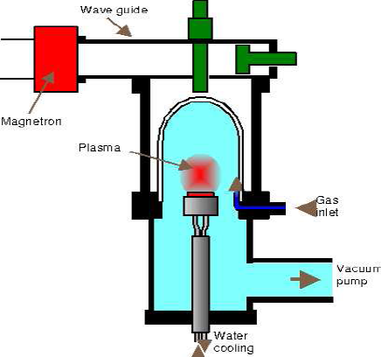
Fig. 1 Micro-Wave Reactor Schematic¹

Research Progress
Diamond is to be grown in microwave reactor. Samples are going to be characterized using Micro-Raman and UV-Vis. Build and test the sensor in extreme envieronment.

Acknowledgements
To NASA-Missouri Space Grant Consortium for funding this research. Also to the Nuclear Science and Engineering Institute, especially my advisors Mark Prelas and Tushar Ghosh for sharing all their knowledge with me and Adrian Mendez for guiding me in the process. Thank you.
References
¹ H. Kagan Diamond (Radiation) Detectors are Forever! , IWORDID 2004
² A.J. Chiquito, O.M. Berengue, E. Diagonel, J.C. Galzerani Temperature sensors based on synthetic diamond films
³ Lin, Microwave/Nuclear Excitations of Alkali Metal Vapors Ph.D 1994

